# INFDTA01-1 Recommender systems

## Results assignment 1: User-item

### Given the 3 nearest neighbours of user 7 (computed with Pearson), predict the ratings that user 7 would give to items 101, 103, 106.

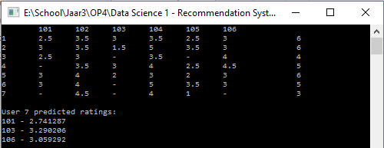

### Given the 3 nearest neighbours of user 4 computed with Pearson, predict the rating that user 4 would give to item 101.

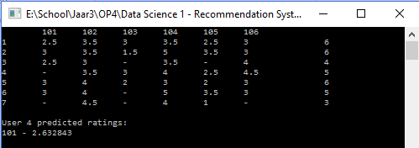

### Suppose now that user 7 rates the item 106 with 2.8. Add this rating into your dataset and update the 3 nearest neighbours of user 7 using Pearson. Compute again the predicted ratings of the other items (101 and 103).

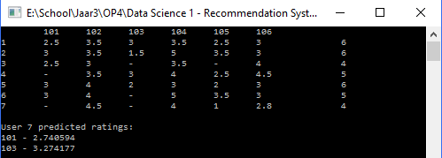

### Suppose that user 7 changes his mind and updates the rating of item 106 to 5. Update the rating into the dataset and update also its 3 nearest neighbours (using Pearson). Compute again the predicted ratings of the other items (101 and 103).

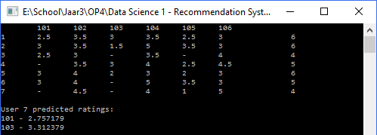

### Using the MovieLens dataset, consider user 186 and create a list of the 8 top recommendations for him, together with their predicted rating.

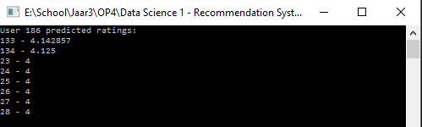

### Modify your algorithm to compute the predicted ratings considering only products rated by at least 3 neighbours. Execute again the program to create the list of 8 top recommendations for user 186.

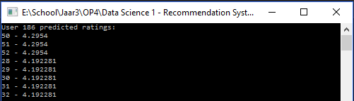

## Results assignment 2: Item-item